THE ONE-ON-ONE COACHING PROGRAM QUESTIONNAIRE

- Year Started in real estate : _______________
- What has been your annual income in the past 3 years:
- Last year: ___________________
- 2 years ago: _________________
- 3 years ago: _________________
- What do you expect your annual income to be in the future:
- This year: _____________
- Next year: _____________
- Why did you enroll in One-On-One coaching?
- ________________________________________________________________________________________________________________________________________________________________________________________________________________________________________________________________
- What are your 3 biggest frustrations in your business today?
- _______________________________________________________________
- _______________________________________________________________
- _______________________________________________________________
6. Based on the current condition of your business, what do you expect this One-On-One Coaching will do for your business?
____________________________________________________________________________________________________________________________________________
____________________________________________________________________________________________________________________________________________
____________________________________________________________________________________________________________________________________________

7. What kind of effect do you expect this Coaching to have on your life, if any?
______________________________________________________________________
____________________________________________________________________________________________________________________________________________
____________________________________________________________________________________________________________________________________________

8. What do you think will be necessary for you to reach the objectives you listed in the two questions above?
______________________________________________________________________
____________________________________________________________________________________________________________________________________________
____________________________________________________________________________________________________________________________________________

9. In building your ideal business, who do you think will be doing most of the actual business development work? You? Your coach? Both you and your coach?
______________________________________________________________________
____________________________________________________________________________________________________________________________________________
____________________________________________________________________________________________________________________________________________

10. How many hours per day do you expect to invest in your business? ____________

11. What other expectations do you have about Coaching?
____________________________________________________________________________________________________________________________________________
____________________________________________________________________________________________________________________________________________

12. Take a look at each of the qualities listed below and think about yourself and where your own attitudes and behavior fall on the scale shown. For each quality, the box which best indicates your level of development.

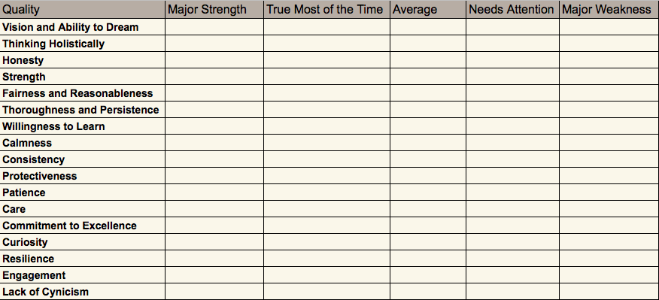

13. Take your time to answer the following questions in the space provided. Write the first response that comes to mind. The questions are designed to help you think about your role as an entrepreneur, and to provide a snapshot of your current business condition.

- What inspires you most about your business? ________________________________________________________________________________________________________________________________________________________________________________________________________________________________________________________________________________________________________________________________________________________________________________________________
- On a scale of 1 to 10, 10 being highest, how do you rate yourself as a leader and why? ________________________________________________________________________________________________________________________________________________________________________________________________
- Do you have a clear picture of where you would like your business to be in five years? ________________________________________________________________________________________________________________________________________________________________________________________________
- How do you track whether or not you are on target to achieve your vision for the business? ________________________________________________________________________________________________________________________________________________________________________________________________________________________________________________________________________________________________________________________________

- What is your most important business goal over the next 12 months? ________________________________________________________________________________________________________________________________________________________________________________________________________________________________________________________________________________________________________________________________

- Do you write down personal goals or objectives on a regular basis? ________________________________________________________________________________________________________________________________

- Do you have a good balance between your work and personal life? ________________________________________________________________________________________________________________________________

- Do you feel that you are in control of how you spend your time? _______________________________________________________________________________________________________________________________

- How would you describe strategic thinking? ________________________________________________________________________________________________________________________________________________________________________________________________

- On a scale of 1 to 10, 10 being highest, how would you rate yourself as a strategic thinker? ________________________________________________________________

- Describe the business activity you believe represents the most strategic use of your time. How much time do you spend on that activity? ________________________________________________________________________________________________________________________________________________________________________________________________________________________________________________________________________________________________________________________________________________________________________________________________________________________________________________________________________________________________________________________________________________________________________________________________________________________________________________________________

- Do you delegate work? If no, why not? ________________________________________________________________________________________________________________________________________________________________________________________________________________________________________________________________

- Which area of the business is most in need of better structure or organization? ________________________________________________________________________________________________________________________________________________________________________________________________________________________________________________________________

- How do you define the overall financial goals of your company? ________________________________________________________________________________________________________________________________________________________________________________________________________________________________________________________________

- Which key metrics do you review to understand the health of your business at any given point in time? ________________________________________________________________________________________________________________________________________________________________________________________________________________________________________________________________

- Can you describe the relationship between your business activities/decisions and your production level? ________________________________________________________________________________________________________________________________________________________________________________________________________________________________________________________________

- Do you have a budget? How do you use it? ________________________________________________________________________________________________________________________________________________________________________________________________________________________________________________________________________________________________________________________________________________________________________________________________

- Do you feel comfortable with your business cash reserves? ________________________________________________________________________________________________________________________________________________________________________________________________

- What is the one thing you want every customer or client to know about your brand/service? ________________________________________________________________________________________________________________________________________________________________________________________________

- On a scale of 1 to 10, 10 being highest, how well do you understand your customers? ________________________________________________________________________________________________________________________________________________________________________________________________

- Describe your target customer: ________________________________________________________________________________________________________________________________________________________________________________________________

- Why should they use your services? ________________________________________________________________________________________________________________________________________________________________________________________________________________________________________________________________________________________________________________________________________________________________________________________________

- Where are your customers located? How effective have your efforts been in reaching them? ________________________________________________________________________________________________________________________________________________________________________________________________________________________________________________________________________________________________________________________________________________________________________________________________

- What do you think differentiates you from your competitors? ________________________________________________________________________________________________________________________________________________________________________________________________________________________________________________________________________________________________________________________________________________________________________________________________

- How do you view your overall market potential? ________________________________________________________________________________________________________________________________________________________________________________________________________________________________________________________________________________________________________________________________

- On a scale of 1 to 10, 10 being highest, how well do you understand the needs of your customers? ________________________________________________________________________________________________________________________________________________________________________________________________________________________________________________________________________________________________________________________________

- What is the number one compliment you hear from customers? ________________________________________________________________________________________________________________________________________________________________________________________________

- What is the number one complaint you hear from customers? ________________________________________________________________________________________________________________________________________________________________________________________________

- What is it about your customer’s experience that makes you proud? ________________________________________________________________________________________________________________________________________________________________________________________________________________________________________________________________________________________________________________________________________________________________________________________________

- How do you attract customers/leads? ________________________________________________________________________________________________________________________________________________________________________________________________________________________________________________________________________________________________________________________________________________________________________________________________
- Do you feel your sales process is effective and produces desired results? ________________________________________________________________________________________________________________________________________________________________________________________________

- Do you have repeat customers? ________________________________________________________________________________________________________________________________

- Do your customers refer you business? ________________________________________________________________________________________________________________________________________________________________________________________________

- On a scale of 1 to 10, 10 being highest, how well does your company deliver a consistent, quality experience to your customers? ________________________________________________________________

- How prepared are you and your business to leverage new ideas? ________________________________________________________________________________________________________________________________________________________________________________________________

- Is there anything else you would like to inform your coach about that wasn’t covered in our questionnaire? ________________________________________________________________________________________________________________________________________________________________________________________________________________________________________________________________

